General Configuration - Lp
URL
LANGUAGE
CAMPUS
AUTRES
QUEUE

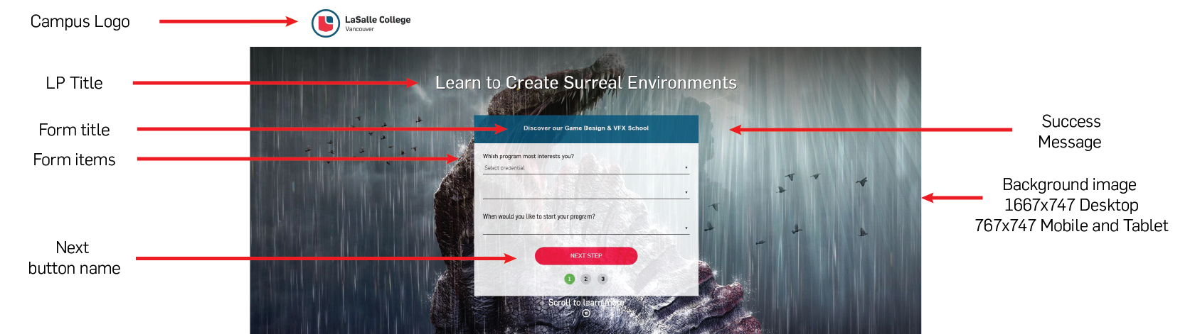

Section form
LP title
Form title
Name next button
Name send button
Success message
Background image
(* Desktop 1667x747 and Mobile 767x747)

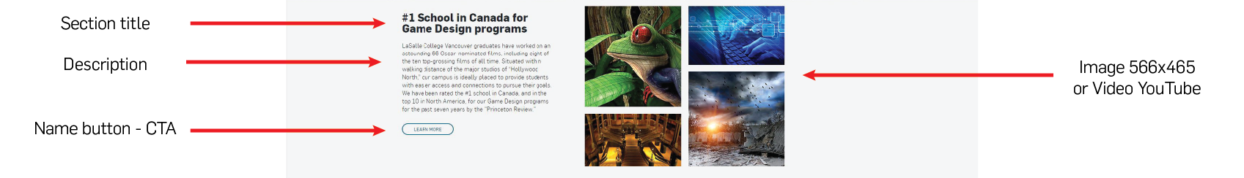

Section 1 – Content with image or video
Section title
Description
Label Button CTA (optional)
Video URL or image
(* 566x465)

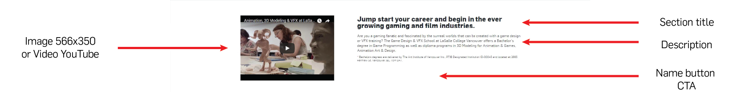

Section 2 – Content with image or video
Section title
Description
Label Button CTA (optional)
Video URL or image
(* 566x350)

Section 3 – Content with image or video
Section title
Description
Label Button CTA (optional)
Video URL or image
(* 566x350)

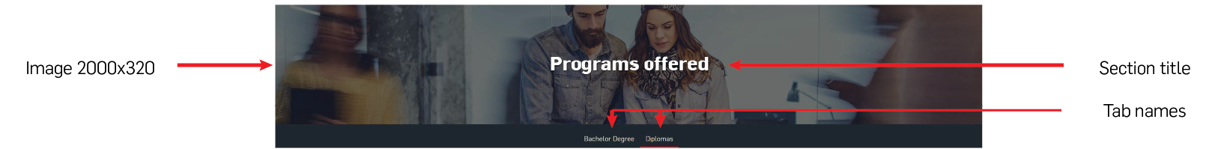

Tabs Section
Section title
Background image
(*.jpg –2000x320)
Tab name 1
Tab name 2
Tab name 3
Tab name 4

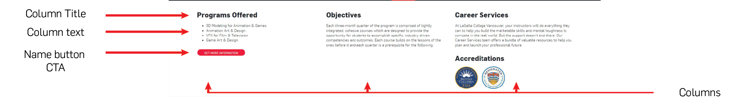

Tab 1
Column 1
Column title
Column description
Label Button CTA (optional)
Column 2
Column title
Column description
Label Button CTA (optional)
Column 3
Column title
Column description
Label Button CTA (optional)

Tab 2
Column 1
Column title
Column description
Label Button CTA (optional)
Column 2
Column title
Column description
Label Button CTA (optional)
Column 3
Column title
Column description
Label Button CTA (optional)

Tab 3
Column 1
Column title
Column description
Label Button CTA (optional)
Column 2
Column title
Column description
Label Button CTA (optional)
Column 3
Column title
Column description
Label Button CTA (optional)

Red band section
Section title
Description
Label Button CTA
Link button

