General Configuration LP
URL
LANGUAGE
CAMPUS
AUTRES
QUEUE OR EVENT

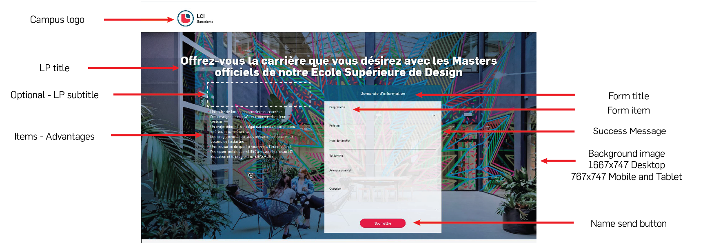

Form Section
LP Title
LP Subtitle
Items – Advantages
Form title
Success message
Label send button
Background Image
* Desktop (1667x747) and mobile (767x747)

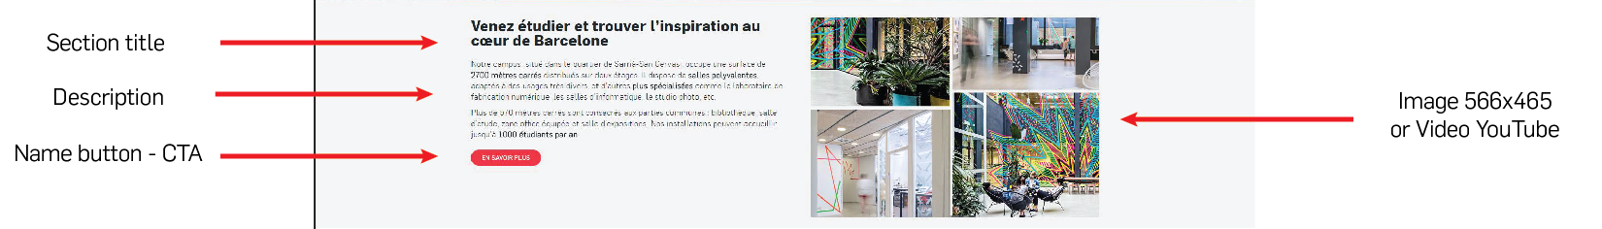
Section 1 - Content with image or video
Section title
Description
Label Button CTA (optional)
Video URL of Image
( * taille 566x465)

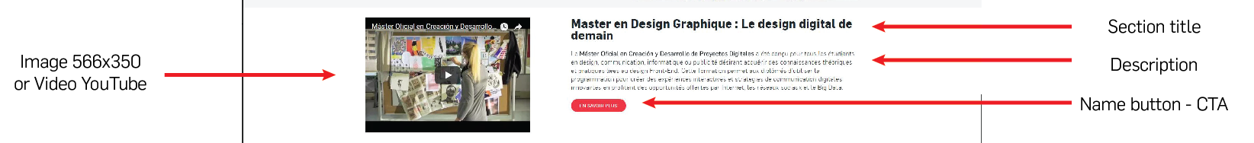

Section 2 - Content with image or video
Section title
Description
Label Button CTA (optional)
Video URL of Image
(* taille 566x350)

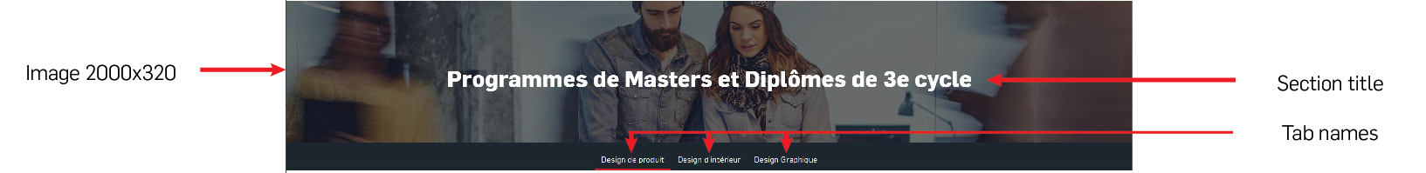
Tabs Section
Section title
Image
(* taille 2000x320)
Tab 1
Tab 2
Tab 3
Tab 4

Tab 1
Column 1
Column title
Column Description
Label Button CTA (optional)
Column 2
Titre colonne
Column Description
Label Button CTA (optional)
Column 3
Column title
Column Description
Label Button CTA (optional)

Tab 2
Column 1
Column title
Column Description
Label Button CTA (optional)
Column 2
Column title
Column Description
Label Button CTA (optional)
Column 3
Column title
Column Description
Label Button CTA (optional)

Tab 3
Column 1
Column title
Column Description
Label Button CTA (optional)
Column 2
Column title
Column Description
Label Button CTA (optional)
Column 3
Column title
Column Description
Label Button CTA (optional)

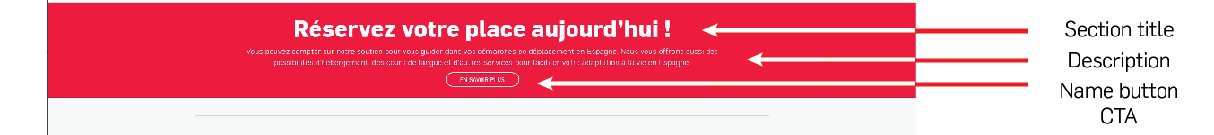
Red band Section
Section Title
Description
Label Button CTA (optional)
Link button

